

Self Start Body Smart at Marcotte Physiotherapy

Assignment Workbook

Winter 2017

Revision History

|  |  |  |  |  |
| --- | --- | --- | --- | --- |
| **Date** | **Time** | **Issue** | **Description** | **Author** |
| 06/12/2017 |  | Fall 2017 | Final E-R Diagram Created | Leo Zhang, Sooruj Ghangass, Tomiwa Ademidun, Andrew Hart, Nicholas Vukelic, Brian He |
| 06/12/2017 |  | Fall 2017 | Final Report Created – All Sections | Leo Zhang, Sooruj Ghangass, Tomiwa Ademidun, Andrew Hart, Nicholas Vukelic, Brian He |
| 24/01/2018 | 8:00 pm | Winter 2018 | Created the routes for all entities | Tharmiga Loganathan, Brian He, Leo Zhang |
| 24/01/2018 | 7:00pm | Winter 2018 | Created the schemas/models for all entities | Sooruj Ghangass, Nicholas Vukelic, Andrew Hart |
| 24/01/2018 | 9:00pm | Winter 2018 | Created the node server | Tharmiga Loganathan |
| 25/01/2018 | 5:00pm | Winter 2018 | Update SDS based on provided schema and the up-to-date back-end | Nicholas Vukelic, Andrew Hart |
| 25/01/2018 – 29/01/2018 | Various | Winter 2018 | Overall code editing for consistency between schemas & routes | All |
| 29/01/2018 | 8:30pm | Winter 2018 | Updated the SDS as per Ouda’s new instructions today | Nicholas Vukelic |

Latest GitHub commits:

|  |  |
| --- | --- |
| **Member** | **Link (Commit ID as per TA Instruction)** |
| Brian He | 36e352e652923c7b6931ab69dd97ffe76f30ffa1 |
| Sooruj Ghangass | 445d06a3a72aa875ede8160c3d789b1f81d0e0fc |
| Andrew Hart | b6e8907e682a374ef70bd6236e7d76c4144ea31b |
| Tharmiga Loganathan | 8059ad550915d6268d6e46c8d4e9c4a27b3f1219 |
| Leo Zhang | f33072b4089f4c34a13381e189ba4d3249fbda93 |
| Nicholas Vukelic | cb61d5333c4460a1817ce4f1b1a628dbe106869e |

*Note: It is impossible to update the latest git commit for Nicholas Vukelic (the one submitting this document) because once the document is committed, there is a new commit ID, which then requires the document to be updated, and so forth.*

Table of Contents

Potential Entity Classes 4

Classes Attributes 5

Entity Class Diagram 9

# Potential Entity Classes

|  |  |
| --- | --- |
| Class name | Brief Description |
| User Account | Securely stores the username and encrypted password for each user of the system. |
| SelfStart User | Encapsulates common characteristics among all users. In practice, it is not implemented as a class since it is inherited by classes through a “mandatory, or” relationship. |
| Administrator | Stores specific information for Administrator users. |
| Physiotherapist | Stores specific information for Physiotherapist users. |
| Patient Profile | Stores specific information for Patient users. |
| Forms | Stores information related to each form, such as name and description. |
| Questions | Stores information related to each question, such as the question order and help description. |
| Question Type | Stores the question type for each question. |
| Assessment Tests | Stores information related to each of the assessment tests, including name, author, and description. |
| Test Result | Stores the result of each assessment test. |
| Rehabilitation Plans | Stores information related to the rehabilitation plan, such as name, description, author, goal, and time frame. |
| Exercises | Stores information for each exercise, such as name, description, and multimedia link. |
| Recommendation | Stores information for the recommendations of each assessment test, including the decision made by the physiotherapist. |
| Treatments | Stores the information related to each treatment, such as the assigned date. |
| Payments | Stores the information related to a payment by a patient user, such as amount and note. |
| Country | Stores a list of country names. |
| Province | Stores a list of provinces associated to each country. |
| City | Stores a city for the location of each patient user. |
| Gender | Stores the gender for the patient. |
| Appointment | Stores information related to an appointment the patient has made with the office. |

# Classes Attributes

1. ***User* *Account***

|  |  |  |
| --- | --- | --- |
| **Attribute name** | **Type** | **Brief Description** |
| userAccountName | String | Account name of the user |
| encryptedPassword | String | Encrypted password of the user |

1. ***SelfStart User***

|  |  |  |
| --- | --- | --- |
| **Attribute name** | **Type** | **Brief Description** |
| ID | String | Unique id of the user |
| familyName | String | Last name of the user |
| givenName | String | First name of the user |
| email | String | Email of the user |

1. ***Administrator***

|  |  |  |
| --- | --- | --- |
| **Attribute name** | **Type** | **Brief Description** |
| dateHired | Date | Date hired |
| dateFinished | Date | Date finished |

1. ***Physiotherapist***

|  |  |  |
| --- | --- | --- |
| **Attribute name** | **Type** | **Brief Description** |
| dateHired | Date | Date hired |
| dateFinished | Date | Date finished |

1. ***Patient Profile***

|  |  |  |
| --- | --- | --- |
| Attribute name | Type | Brief Description |
| DOB | Date | DOB of the patient |
| postalCode | String | Postal code of the patient |
| phone | String | Phone number of the patient |
| maritalStatus | String | Marital status of the patient |
| healthCardNumber | Int | Health card number of the patient |
| occupation | String | Occupation of the patient |
| others | String | Other information about the patient |

1. ***Forms***

|  |  |  |
| --- | --- | --- |
| **Attribute name** | **Type** | **Brief Description** |
| name | String | Name of the form |
| description | String | Description of the form |

1. ***Questions***

|  |  |  |
| --- | --- | --- |
| **Attribute name** | **Type** | **Brief Description** |
| questionText | String | Question information |
| helpDescription | String | Additional information about question |
| order | Int | Order in the form |

1. ***Question Type***

|  |  |  |
| --- | --- | --- |
| **Attribute name** | **Type** | **Brief Description** |
| name | String | Category of the question |

1. ***Assessment Test***

|  |  |  |
| --- | --- | --- |
| **Attribute name** | **Type** | **Brief Description** |
| name | String | Name of the assessment test |
| description | String | Description of the assessment test |
| authorName | String | Name of the assessment test author |

1. ***Test Result***

|  |  |  |
| --- | --- | --- |
| **Attribute name** | **Type** | **Brief Description** |
| question | String | Question information |
| answer | String | Response information |

1. ***Rehabilitation Plans***

|  |  |  |
| --- | --- | --- |
| **Attribute name** | **Type** | **Brief Description** |
| name | String | Name of the rehabilitation plan |
| description | String | Description of the rehabilitation plan |
| authorName | String | Name of the rehabilitation plans author |
| goal | String | End goal of the rehabilitation plan |
| timeFrameToComplete | String | Period of time to complete the rehabilitation plan |

1. ***Exercises***

|  |  |  |
| --- | --- | --- |
| **Attribute name** | **Type** | **Brief Description** |
| name | String | Name of the exercise |
| description | String | Description of the exercise |
| objectives | String | Objectives of the exercise |
| authorName | String | Author of the exercise |
| actionSteps | String | Steps taken to complete the exercise |
| location | String | Location of the exercise |
| frequency | Int | Frequency of the exercise |
| duration | Double | Length of time to complete exercise |
| targetDate | Date | Date to finish exercise |
| multimediaURL | String | URL of multimedia link |

1. ***Recommendation***

|  |  |  |
| --- | --- | --- |
| **Attribute name** | **Type** | **Brief Description** |
| injuryType | string | Type of injury (i.e. fracture, concussion, etc.) |
| severity | string | Severity of the injury (i.e. minor, life-threatening, etc.) |

1. ***Treatments***

|  |  |  |
| --- | --- | --- |
| **Attribute name** | **Type** | **Brief Description** |
| dateAssign | Date | Date of treatment assingment |

1. ***Payments***

|  |  |  |
| --- | --- | --- |
| **Attribute name** | **Type** | **Brief Description** |
| dayTimeStamp | Date | Transaction timestamp |
| amount | Double | Transaction amount |
| note | String | Additional information |

1. ***Country***

|  |  |  |
| --- | --- | --- |
| **Attribute name** | **Type** | **Brief Description** |
| name | String | Name of the country |

1. ***Province***

|  |  |  |
| --- | --- | --- |
| **Attribute name** | **Type** | **Brief Description** |
| name | String | Name of the province/territory/state |

1. ***City***

|  |  |  |
| --- | --- | --- |
| **Attribute name** | **Type** | **Brief Description** |
| name | String | Name of the city |

1. ***Gender***

|  |  |  |
| --- | --- | --- |
| **Attribute name** | **Type** | **Brief Description** |
| name | String | Name of the gender, if the patient has chosen to disclose their gender |

1. ***Appointment***

|  |  |  |
| --- | --- | --- |
| **Attribute name** | **Type** | **Brief Description** |
| date | Date | Date of appointment, including time |
| reason | String | Reason for the appointment, as indicated by the patient |
| other | String | Other notes associated with the Appointment, as indicated by the patient |

# Entity Class Diagram

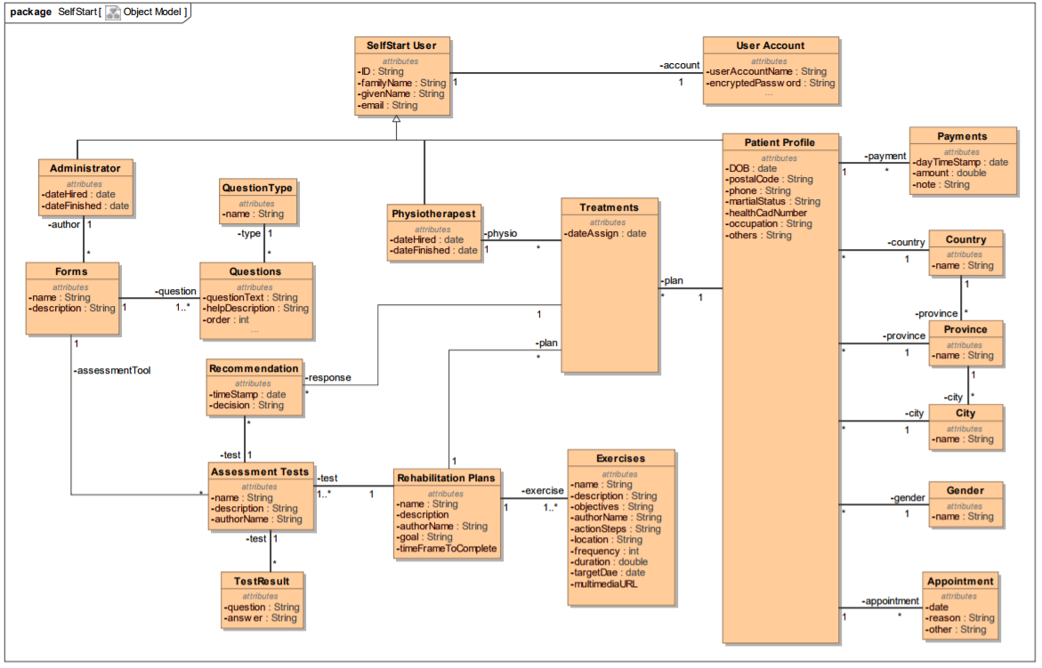

The class diagram above is the same as the database schema for the system. It describes the relationship between all separate entities in the system in a structured way. It has guided the development of the back-end system, where there are the appropriate routes in place to create, update, delete, and get each of the corresponding entities.